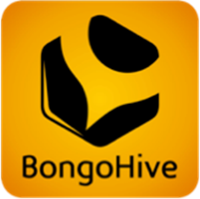  This is the BongoHive Business Canvas, it’s a tool to get your idea and assumptions down on paper. Fill it out thinking about your business in the next 6 to 12 months and not the long term. Over a short period of time, we will test your assumptions and idea until you’re ready to launch your business. If you have any questions, email me at mike@bongohive.co.zm. |  |  |  | Date: Iteration: 1  Name:  Business Name:
1. Customer’s Problem  Describe the top 1-3 problems your customers need solved.  1.  2.  3. | 4. Solution  List the solutions to the 1-3 problems you wrote down in 1. Customer’s Problems.  1.  2.  3. | 3. Unique Value Proposition  A single, clear message of why your product/service is unique and worth buying. |  |  | 9. Unfair Advantage  This is something that cannot easily be bought or copied. | 2. Customers  Who are the specific groups of people that will be your customers
Competition & Alternatives  Who is your direct competition? If it’s a new industry, how are these problems being solved today? | 8. Three Month Targets  List 2-4 targets that you can accomplish in the next three months. | 10. Social/Environmental  What social or environmental impact will result and who are the beneficiaries? |  |  | 5. Communication Channels  How will you connect with your customer segments? | Early Adopters  List the very first customers within your customer segment.
7. Cost Structure  List each specific cost; both those that are fixed and those that vary. |  |  | 6. Revenue Streams  List the ways you intend to make money and be specific. List the selling price and the number of units sold.

